L7

• Small-signal hybrid-π model (draw the small-signal equivalent circuit and name the terminals);（S 18-24/S 225）
画MOSFET Hybrid-π Model时
小写字母代表小信号，因为我们都是在做小信号所以注意写成小写字母
G-S往往可以看作无限电阻（断路）input resistance of a MOSFET gate is infinite.
固定的输入电压可以看为接地
Rds也往往可以被忽略
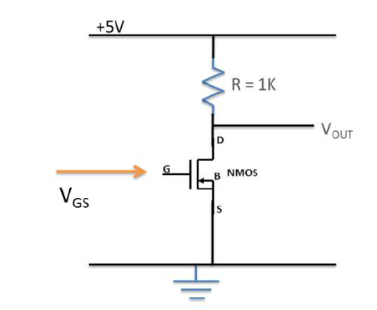
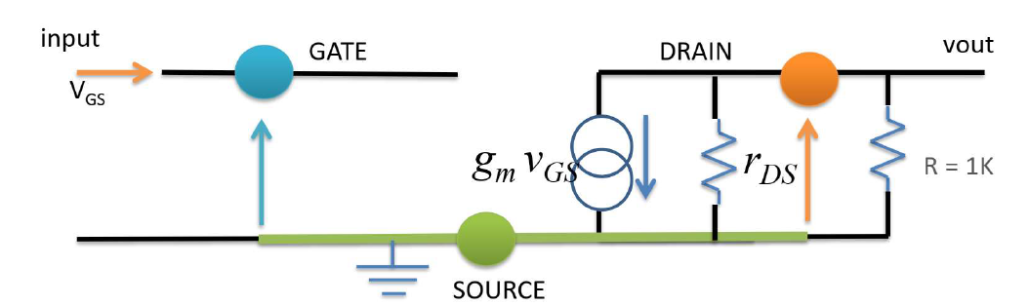
（tutorial 题目）
每个MOS管有三个terminals（G,D,S）
Gm-Vgs是一个电压控制的电流源

• The forward transconductance (gm) and the output resistance (rDS). Understand their relations to large-signal parameters; (S 25/ S232) (S39/ S246)
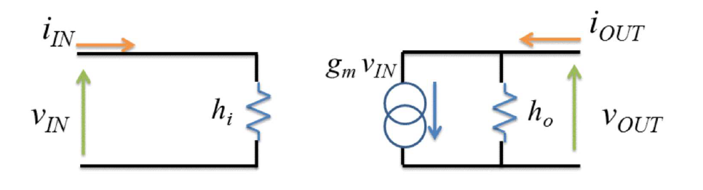
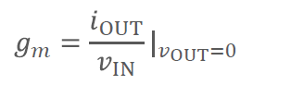
rDS（在单个Mos管时就是上面的ho） is either infinite (ideal MOSFETs), or very high (real MOSFETs).
对于大信号的影响个人认为理解就好，数学推导比较复杂，主要跟MOSFET的伏安特性曲线有关
(7条消息) 大信号和小信号的区别_zjy_uestc的博客-CSDN博客_大信号和小信号的区别

• The voltage gain of an ideal common source FET amplifier;（S111/S318）
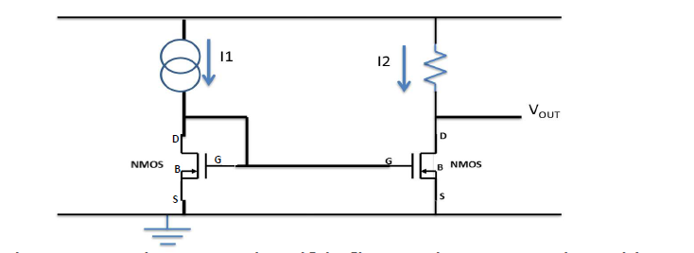
两个MOS管的G,D击都连接的是同样的S极
It designs as the source is common to both the gate and the drain
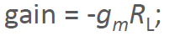
Can also be used as a current mirror circuit, a current multiplier, or a current source.
同理还有common gate FET amplifier，common drain FET amplifier
• Common Source:
Amplifier, gain = -gmRL;
Can also be used as a current mirror circuit, a current multiplier, or a current source.
• Common Gate:
Rarely used as an amplifier (except for some high frequency applications);
Now used mostly as switches.
• Common DRAIN / Source Follower: A level shifter; A buffer to protect weak signals.

• Understand what clipping is and how to prevent it;(tutorial 3原题，S 32/ S239)
Clipping is a small-signal failure. It occurs when the signal you are amplifying hits either the maximum or minimum voltage and thus it becomes flatlines as it cannot go past either of these limits.
To avoid it, set the bias point such that the signal is away from the edges. However, if the signal is too large, clipping becomes inevitable.

• Three common biasing schemes (fixed biasing, voltage-divider biasing, and drain-feedback biasing);（L7 S51/ S258以及L6的知识）
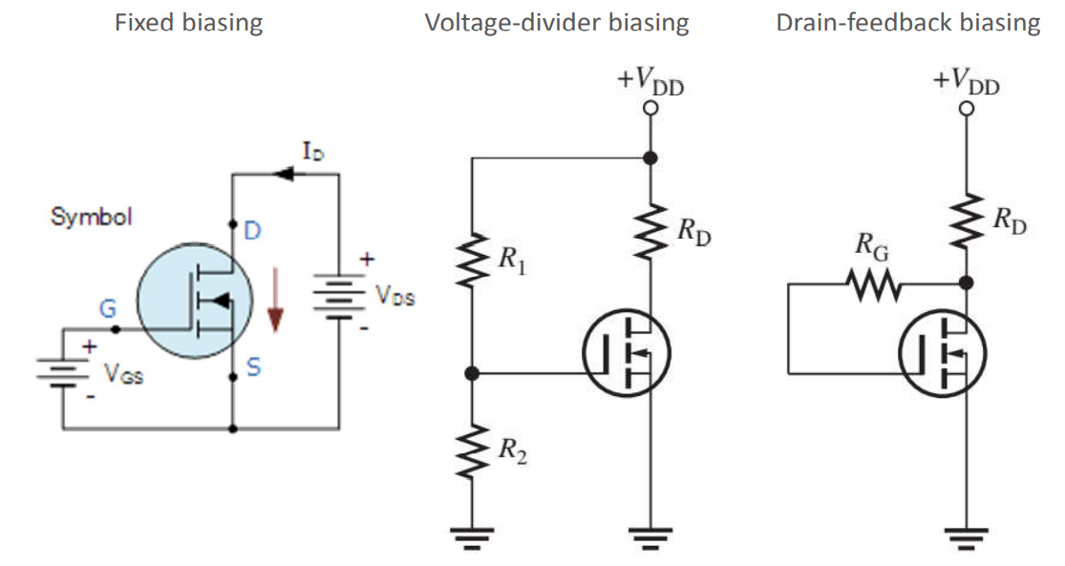
个人认为Voltage-Divider Biasing是要点（稍微有点难但不完全难）
tutorial3最后两道就是Voltage-Divider Biasing的相关题目

• The use of (de)-coupling capacitors;（S56/S263）（S74/S281）
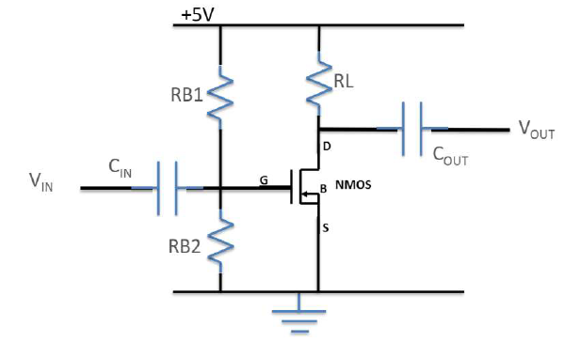
通过在输入输出端添加电容来消除直流电压部分的影响，从而保证
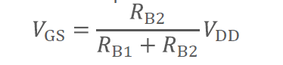
VDD是CMOS电路的正电压;

• The influence of CGS and CGD on FET amplifier output;（S86/S293）挺难的具体数学过程看课件
CGS意味着理论上（不考虑电容时）的增益与实际增益间，关于频率的关系
结论性的公式是这个
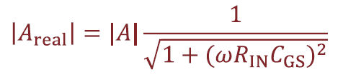
• if ω << 1/(RINCGS), then Areal = A;
• if ω = 1/(RINCGS), then Areal ≈ 70.7% of A; 就是3db
• if ω >> 1/(RINCGS), then Areal ≈ 0.
The equivalent input capacitor CEQ is actually the same as the CGD capacitor multiplied by (1 - A)

• The Miller effect;（S94/S303）

The Miller effect says that from the perspective of the INPUT, an impedance (capacitor, inductor, resistor) going from input to output is scaled up by the gain of the amplifier. This is a big problem for high-gain systems.
• This is an approximation and does not cover all effects of that impedance.
CGS is the biggest in size but CGD has the biggest impact.

• Current mirror and current multiplier (S100-101 /S307);
• The transistor equation says that if ID flows, there must be a VGS;
• The two transistors see the exawct same VGS;
• The transistor equation says that given a value of VGS, a current ID will flow;
• In an ideal case (provided that VT1 = VT2), ID does not depend on VDS, so therefore I1 = I2;
• Where there is a dependency on VDS (real case), I2 will differ slightly from I1;
• This is called a current mirror or current multiplier.
我曾经发的那个电路模拟APP有这个简单电流镜的演示电路，电流镜会复制一份与l1相似的电流l2

• The source follower circuit.(S102/S309) 个人认为较有难度了，tutorial3的最后一题同一类型(因为难度太大所以我认为不会考)
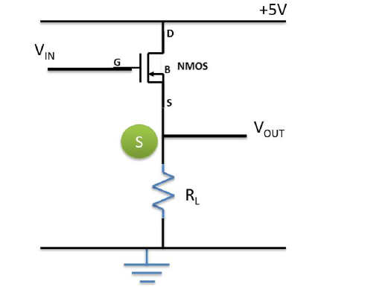
像这种电路，S极是Vout输出，就是电源输出电路。（The output is taken at the source.）
做这种题先化成我们常见的模型，然后分析Gain
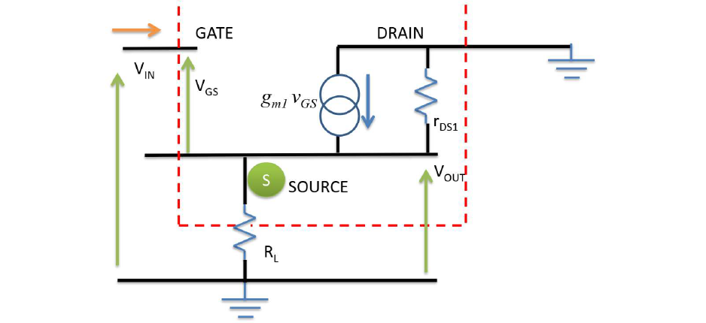
Vin不是Vgs了，往往要联立设未知量求解

L8

• Ideal op-amps vs. practical op-amps;（tutorial，原题）(S2/S320)

理想运放
- 无限输入阻抗:理想的运算放大器输入端不容许任何电流流入，即图中的V+与V-两端点
- 零输出阻抗:理想运算放大器的输出端是一个完美的电压源，无论流至放大器负载的电流如何变化，放大器的输出电压恒为一定值，亦即输出阻抗为零。
- 无限开环增益:理想运算放大器的一个重要性质就是开回路的状态下，输入端的差动信号有无限大的电压增益，这个特性使得运算放大器十分适合在实际应用时加上负反馈组态
- 其他特性包括零偏置电压、无限带宽、无限共模抑制比等。
实用运放:非常高的输入阻抗，低的输出阻抗，几乎无限(非常高)开环增益。实际运放具有非零偏置电压和相对较小的带宽(应用适当的负反馈可以增加带宽)。

Ideal Op-Amp
• They amplify the DIFFERENCE of two inputs;
• They have INFINITE input impedance;
• They have ZERO output impedance;
• They have INFINITE gain.
Some other characteristics also include zero offset voltage, infinite bandwidth, etc.

Practical Op-Amp
• They amplify the DIFFERENCE of two inputs;
• They have very high input impedance
• They have very low output impedance
• They have nearly INFINITE gain

• Advantages of a high input impedance and a low output impedance;(S4/S322)
high input impedance
To make VIN = VSOURCE, we need to make IIN zero, or make RIN infinitely large.
Pulling current from a high output impedance source drops voltage.

low output impedance
Reducing ROUT will mean that we get more current and thus more rapid charging/discharging of the capacitors. ROUT = 0 would mean infinitely fast changes in the output voltage

• Slew rate;（tutorial4和去年考题的原题）（S7/S325）

转换速率是运算放大器输出能改变的最快速度。这取决于连接到输出端的电容的大小。当输出被要求改变时，电容和电感的存在将使改变变慢——电容通常是问题所在。不存在无限快的转换速率，因为这意味着零输出阻抗（无限电流传输）或零电容。转换速率SR (Slew Rate)表示输出电压在规定的单位时间可变化的比例。

转换速率描述运算放大器快速改变输出的能力，因此，它定义了给定运算放大器的最高工作频率。转换速率限制了运放电路的性能，如果超过了它的限制，它可以扭曲输出波形。

• When the output is about to change, the presence of capacitors and inductors will slow down the change – capacitors are usually the problem.
• The slew rate is the fastest speed at which an output can change. It is of course dependent on the amount of capacitance connected to the output.
• There is no such thing as infinitely fast slew rates as that would mean zero output impedance (infinite current delivery) or zero capacitance.

• Open-loop gain vs. closed-loop gain;

本质上看就是有没有输出的反馈
open loop
A=Vout/Vin

closed loop
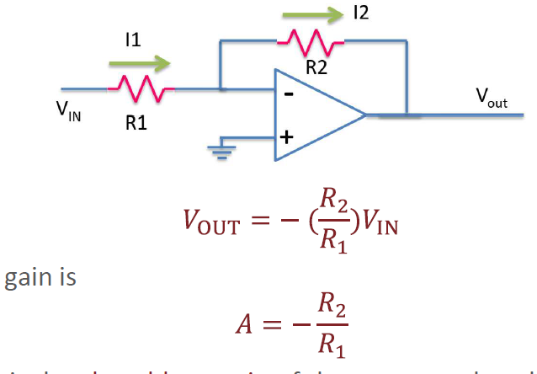
We call this the closed-loop gain of the system – closed because there is feedback. The gain without feedback is called open-loop gain.

• Common op-amp circuits with negative feedback (voltage follower, inverting amplifier, summing amplifier, differential amplifier, and non-inverting amplifier);这俩题只说了名字，内容涵盖了lecture8从10到60所有的内容，没法整理了

• Integrator and differentiator, first-order active filters (low-pass and high-pass), and Sallen-Key filters (low-pass and high-pass).

L9
BJT和FET的区别
